Sports Gala 2025
UET LAHORE CS DEPARTMENT
GEAR UP FOR THE MOST EXCITING EVENT

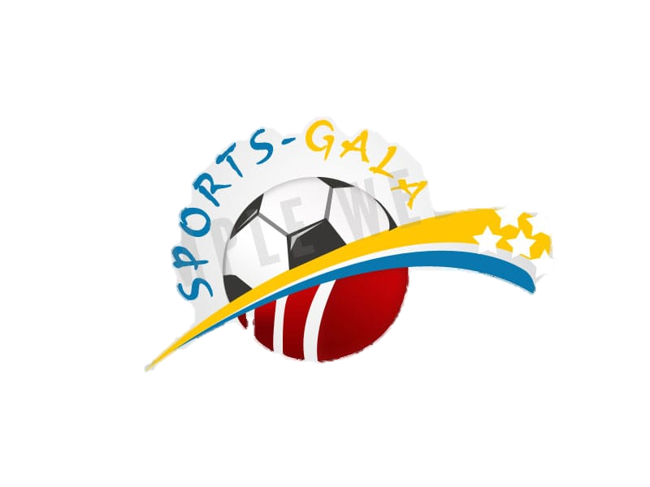

OCTOBER 29, 2025
JUNAID JAMSHAID STADIUM

